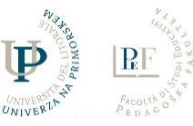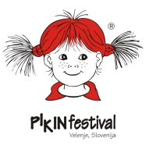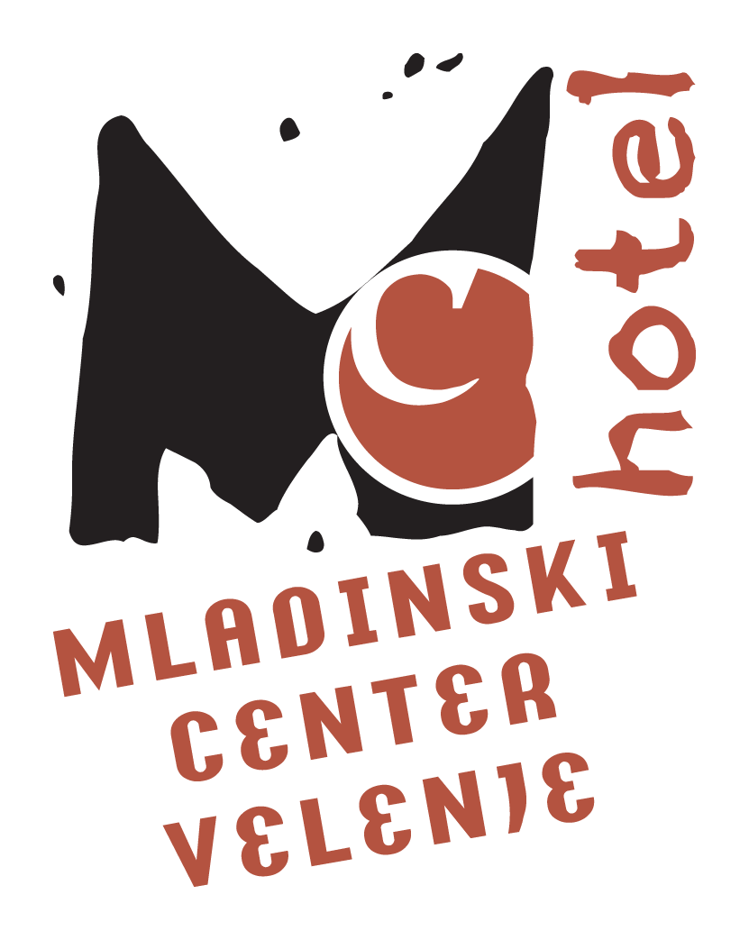


2nd INTERNATIONAL DANCE PEDAGOGY CONFERENCE
October 10 - 12 2014, Velenje, Slovenia
SCHEDULE

SCHEDULE
Registration will take place on Friday from 8.15 AM in the lobby of the House of Culture Velenje. Throughout the duration of the conference, a reading room will be opened in the House of Culture Velenje lobby, showcasing expert literature. Also open will be a small bookshop for purchasing selected texts.

Friday, October 10, 2014
Time | House of Culture Velenje - stage | Lobby of the House of Culture | Center NOVA hall | Gaudeamus hall
8.15 – 9.00 AM | Registration (in the lobby)
9.15 – 9.30 AM | Welcome addresses
9.30 – 11.00 AM | Plenary lectures  Simona Tancig: Neuroeducation and Embodied Cognition – Views of Movement and Dance Activities  Lynnette Young Overby: A Dance/Arts Integration Approach to Embodied Cognition  Vesna Geršak: The way of thinking
11.30 AM – 1.00 PM | Bojana Caf: Dance-Movement Therapy in the Role of Strengthening the Social Skills of Children with Special Needs  Vesna Geršak: Examples of Inclusion of Creative Movement into Learning, from Kindergarten to University | Federation: Museum Comes to Life
1.00 PM | Lunch
2.30 – 4.00 PM |  | Federation: Museum Comes to Life |  | Vilma and Urša Rupnik: Presenting a Textbook Art of dance
4.15 – 5.45 PM |  |  | Breda Kroflič: Pinkate Ponkate – Voices in Movement and Games, Creative Movement Workshop running by Handbooks of Speech Therapist Bernardka Lesjak Skrt | Round table – Presentation of professional papers
6.00 – 7.30 PM | PIKA MIGA (part 1)
7.30 PM |  | Social evening
Saturday, October 11, 2014
Time | House of Culture Velenje - stage | Center NOVA hall | Gaudeamus hall
9.00 – 10.30 AM |  | Elisabeth Zimmermann: Playing and Dancing as Ways of Making Sense of the World  Elisabete Monteiro: daCi Portugal – Challenges and Constraints  Nina Meško: Optional Elective Course Art/Dance for the Second Triad of Primary School
11.00 AM – 12.30 PM | PIKA MIGA (part 2) | Sinja Ožbolt: Improvisation and Composition
12.30 PM | Lunch
2.00 – 3.30 PM | Lynnette Young Overby: Thinking Tools and the Multi-Disciplinary Imagination: Exploring Observing, Abstraction, Pattern forming and Transforming in Dance and Creative Writing | Gordana Stefanovič Erjavec: The dancers, painters of space and time | Nina Mavec Krenker: Dance Technique can be Fun!
4.00 – 5.30 PM | Elisabete Monteiro: Sparks of Creativity | Neja Kos and Daliborka Podboj: Understanding and Analysing Dance Performances
5.30 – 7.00 PM | Elisabete Monteiro: Sparks of Creativity |  | PIKA MIGA (part 3: OPUS) and a conversation with the young dancers and their mentors

Sunday, October 12, 2014
Time | Youth Hostel Velenje – lecture hall | Center NOVA hall | Gaudeamus hall
9.00 – 10.30 AM | Lynnette Young Overby: Arts Integration – a Pathway to Student Engagement and Success | Elisabeth Zimmermann: Under Construction | Gordana Schmidt: Dance Theatre
10.45 AM – 12.15 PM |  | Petra Pikalo: Dance Dramatization | Jelka Kapun: Dance Moments from the Kindergarten
12.30 PM | Concluding ceremony and issuing of certificates

Legend:

- Lecture
- Workshop
- Panel debate and other activities
- Demonstration workshop
- Performance

Addresses of the conference venues:
House of Culture Velenje, Titov trg 4, Velenje
Youth Hostel Velenje, Efenkova 61a, Velenje
NOVA lecture hall – Center Nova, Šaleška 21, Velenje
Gaudeamus hall, Trg mladosti 3, Velenje

