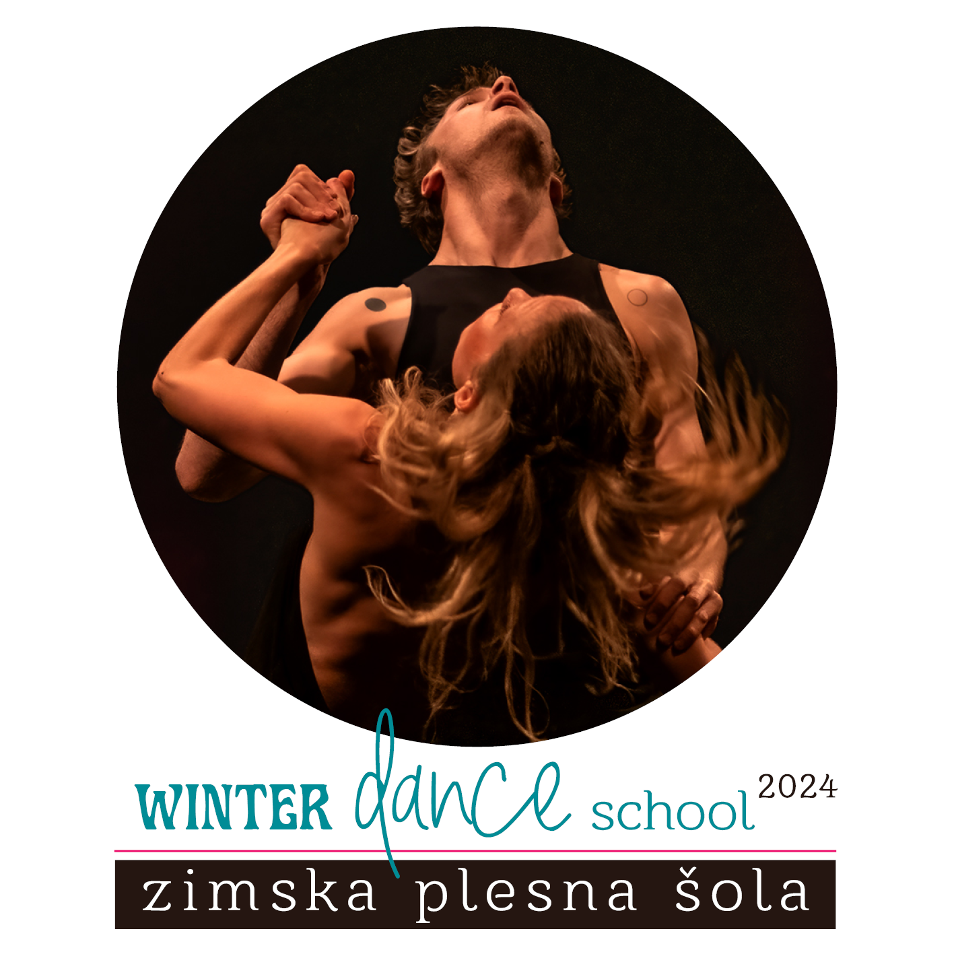

APPLICATION FORM
39th WINTER DANCE SCHOOL from February 23 to 26, 2024
(Early bird 2nd of February)

Name and Surname |  |  |  |  |  |  |  |  |  |  |  |  |  | Year of Birth
Address (street, post code, city)
Phone (mobile) |  |  |  |  |  |  |  |  |  |  |  |  | E-mail:
Dance activity (group, school, company)
PROGRAMME (highlight the chosen classes)
Ballet for contemporary dancer – Tina Dobaj | I | II-III
Feldenkrais Into dance – Simon Wehrli | I-III
Follow the Flow – Urša Rupnik | I | II-III
Contemporary dance – Maša Kagao Knez | I
Flying Low – Jasmina Križaj |  | II-III
Workshop It’s a match – Simon Wehrli | I-III
Workshop Between external and internal rhythm – Anja Mejač | I-III
Qi Gong – Tina Dobaj | I-III
Afro fusion – Maša Kagao Knez | I-III

City: |  |  |  |  |  |  |  | Date: |  |  |  |  |  |  | Signature:

I – BASIC: less experienced

II – INTERMEDIATE: more experienced
III – ADVANCED: very experienced, professional
FULL TITLE OF THE PAYER
(highlight!) |  |  |  |  |  |  | alone |  |  |  | Institution / school/ other
Institution/school/other
Address /street, city
Poste code |  |  |  |  |  |  |  |  |  |  |  | City
Phone (mobile) |  |  |  |  |  |  |  |  |  |  |  | E-mail
Tax number/VAT: |  |  |  |  |  |  |  |  |  |  |  | Amount: |  | €
City and date: |  |  |  |  |  |  |  |  | Signature of a responsible person for payment:
 |  |  |  |  |  |  |  |  | Rubber stamp:
Lower prices are valid if applications and payments are received until 2nd February 2024!
JSKD OI Maribor, Pobreška 20, Karantena, 2000 Maribor, Slovenia
E-mail: ples.jskd.mb@gmail.com, fax: + 386 2 23 42 112
Warranty: We take no responsibility for injuries and thefts. Regulate your own personal insurance and take care of your belongings.


